Name:____________________________
HOMEWORK #2 – Week 2

This homework is worth 10% of your course grade.

Read each problem carefully. Failure to follow the instructions for a problem will result in a zero score for that problem.

Submit the completed Homework via Assignment in LEO.

1. Construct a truth table for the Boolean equation:
M = A’B C’ + A’B C + A B’C + A B C

A | B | C | M
0 | 0 | 0
1 | 1 | 1

Minimize the function M

2. Draw a simple NOT, AND, OR circuits that represents the equation above (minimized form).

3. The truth table for a Boolean expression is shown below.
- Write the Boolean expression on SOP form
- Minimize the function.
- Draw the SOP form using NOT, AND, OR circuits
- Draw the minimized function using NOT, AND, OR circuits

x | y | z | F
0 | 0 | 0 | 1
0 | 0 | 1 | 1
0 | 1 | 0 | 0
0 | 1 | 1 | 1
1 | 0 | 0 | 1
1 | 0 | 1 | 1
1 | 1 | 0 | 0
1 | 1 | 1 | 1

4. Find the truth table that describes the following circuit:

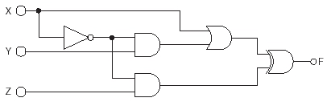
After you write the truth table, please minimize the Function F.
Draw the minimized form

5. Describe the function of a decoder circuit;
identify the types and quantity of gates needed to implement a 3-to-8 decoder;
either create (or give the location in the text) of a logic diagram of a decoder circuit

If we want to buy a 1 of 8 decoder/ demultiplexer, please give the code (part number) of this circuit.
In other words: If I want to buy a decoder, you have to require a code of circuit ((part number) to the seller or you have to provide the code you looking for Purchase Online.
For this you must consult a datasheet catalog of integrated circuits

